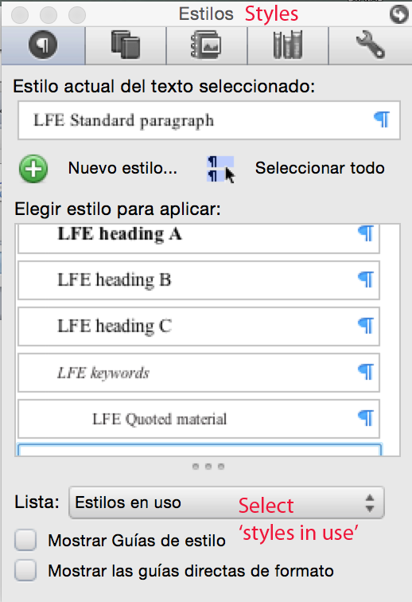
LFE Article Main Title
LFE Abstract title ABSTRACT
LFE Abstract
LFE keywords
LFE Abstract title ABSTRACT (a second language)
LFE Abstract
LFE keywords

1. LFE heading A
LFE Standard paragraph
- LFE Bulleted
- LFE Bulleted
- LFE Bulleted

1.1. LFE heading B
LFE Standard paragraph

3.1.1. LFE heading C
LFE Quoted material [quotations]
LFE Standard paragraph
(1) LFE First example in a list (First)
(2) LFE Second, third fourth example (Second)
(3) LFE Last example in a list (Last)
LFE Standard paragraph
(1) LFE Example (Single)
LFE Table first raw | LFE Table first raw | LFE Table first r
LFE Table | LFE Table | LFE Table
LFE Table | LFE Table | LFE Table

Figure/Table X. LFE Figure caption.
LFE Standard paragraph

LFE About the author
Please do not fill this in at this stage. You will be notified to give this information after acceptance.

LFE Acknowledgements
Please do not fill this in at this stage. You will be notified to give this information after acceptance.

References LFE BIB Title
LFE Bibliography Style
Make also sure that your references meet the Journal’s style. We include some examples, below:

{BOOK} Davis, Ll. (1998). Sexuality and gender in the English Renaissance: An annotated edition of contemporary documents. London: Taylor & Francis.
{ARTICLE} Downing, A. (2001). ‘Surely you knew!’ Surely as a marker of evidentiality and stance. Functions of Language, 8(2), 251-282.
{ONLINE} Spencer, H. (1927). Wolveridge’s ‘Speculum Matricis’. Proceedings of the Royal Society of Medicine (pp. 56-62). <http://www.ncbi.nlm.nih.gov/ pmc/articles/PMC2100830/pdf/procrsmed01198-0062.pdf> [10/12/2010].
{BOOK CHAPTER} Taavitsainen, I. & Pahta, P. (1995). Scientific ‘thought-styles’ in discourse structure: Changing patterns in a historical perspective. In B. Wårvik, S. K. Tanskanen & R. Hiltunen (Eds.), Organization in discourse: Proceedings from the Turku Conference (pp. 519–29). Turku: University of Turku.

LFE Appendix Title
LFE Standard paragraph

LFE Footnote

